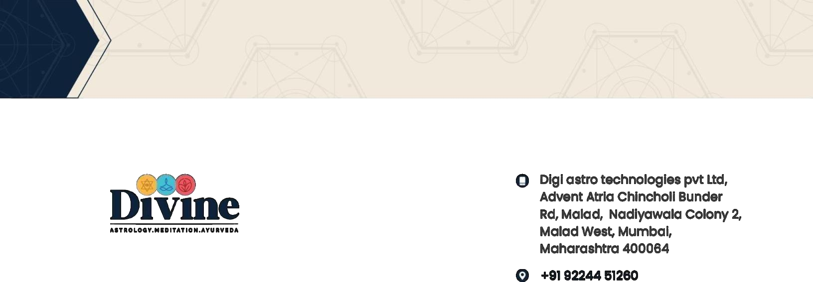

Date: 22 Aug, 2025

Internship Name: Abhishek Kumar

Dear Abhishek Kumar

We are pleased to confirm our offer of internship to you as a **Software Developer Intern** with **Digi Astro Technologies Private Limited** (“the Company”), effective from **23rd August, 2025**.

Upon your acceptance of this offer, and subject to the successful completion of all onboarding prerequisites to the satisfaction of the Company, your initial appointment will be at **Gurgaon, Haryana**. This internship will be conducted **from the office premises**, and your physical presence will be required as per the working hours defined by the Company.

The Offer Letter Includes the Following Annexures:

• **Annexure I**: List of Required Documents

• **Annexure II**: Internship Terms & Conditions

• **Annexure III**: Stipend Structure

• **Annexure IV**: Non-Disclosure and Confidentiality Agreement

• **Annexure V**: Non-Compete & Intellectual Property Agreement

You are required to carefully read and understand these documents. Your internship with the Company will be governed by the terms stated in the above annexures.

This offer is contingent upon submission and verification of the documents comprising educational credentials, reference checks, previous employment history inclusive of relieving letters and last drawn salary slip. The Company reserves the right to terminate your employment if any information provided to the company was found wrong and/or you have intentionally provided incomplete information. We are pleased to have you as a member of the team. We look forward to your joining and we wish you a successful career ahead.



ANNEXURE I

REQUIRED DOCUMENTS

The following documents required to be submitted are mandatory: -

1. The relieving letter or resignation acceptance letter from your most recent employer. If you have been employed for 1 year or less with the most recent employer, you must also bring a relieving letter or resignation acceptance letter from the prior employer.
2. The originals and self-attested copy for submission: -
   1. Education degree certificate and all year mark sheets for the highest degree attained (include both front and back sides of the certificate.
   2. Class 10th Marksheet and Class 12th Marksheet.
   3. Photo ID proof (Aadhar Card, Driving License or voter’s identification card)
   4. Proof of current Address and Permanent Address respectively with full particulars (Passport, Electricity Bill, Water Bill, Mobile Bill, Gas Connection etc.)
3. Cancelled Cheque giving complete account details
4. PAN Card (scanned copy)
5. Salary Slips for the last 3 months (if applicable)

# Annexure-II: Terms of Internship

TERMS OF INTERNSHIP :

Your internship with Digi Astro Technologies Private Limited (hereinafter referred to as the “Company”) will be governed by the Company’s internship policies and code of conduct, which may be modified from time to time at the Company’s sole discretion, upon notice to you. These Terms of Internship must be read along with all applicable Company policies, including the Internship Code of Conduct. Any updates will be communicated in advance.



EFFECTIVE DATE OF JOINING AND LOCATION

Your effective date of joining with the Company is **23rd August, 2025**, and the location will be **Gurgaon, Haryana (Work from Office)**.  
However, your services may be transferable to any section, department, or location of the Company, its associates, subsidiaries, or sister concerns, existing now or in the future, at the sole discretion of the Management.  
In such a case, you will be governed by the applicable terms and conditions of the new assignment. If applicable, reimbursement for any relocation or travel expenses will be provided upon submission of valid bills, subject to approval.

# JOB TITLE

Your designation in the Company will be **“Software Developer Intern”**.

PROBATION PERIOD

You will undergo a **performance assessment period of 3 (three) months** from your date of joining. During this period, your performance, discipline, and learning progress will be reviewed by the Company.  
The Company reserves the right to discontinue the internship during this period with 7 days prior notice, subject to proper handover and transfer of any knowledge or assets involved.  
This internship does not imply automatic absorption into a permanent role, but based on your performance and organizational requirements, suitable opportunities may be offered in the future.

FULL TIME EMPLOYMENT

This internship opportunity is full-time in nature, and you are expected to dedicate your complete working hours to the responsibilities assigned by the Company. You shall not undertake any other job, freelancing work, academic course, or business activity during the internship period that may may affect your productivity or create a conflict of interest with the Company.



SALARY/REMUNERATION

You will be paid a **monthly stipend** of **INR 5,000/-**, effective from your date of joining, i.e., **23rd August, 2025**.  
This stipend is a consolidated amount and is not subject to any statutory deductions such as Provident Fund or ESI, unless otherwise applicable under law.  
Taxes, if applicable, will be deducted at source (TDS) as per prevailing income tax norms.

PERFORMANCE REVIEW / CONVERSION

Your performance will be monitored throughout the internship by your mentor or reporting manager.  
Based on your contributions, learning progress, and availability of positions, you may be considered for a **full-time employment opportunity** with the Company upon successful completion of your internship.  
Please note that conversion to a permanent role is entirely at the Company’s discretion and subject to evaluation.

LEAVE POLICY FOR INTERNS

As an intern, you will be eligible for a total of **4 days of casual leave** during your internship period.  
All leaves must be approved in advance by your reporting manager via email.  
You will also be entitled to **official public holidays** observed by the Company during your internship period.  
Any unauthorized absence for more than **2 consecutive working days** without prior intimation will be treated as voluntary discontinuation of the internship.

# ROLES AND RESPONSIBILITIES

1. You are expected to carry out all assigned tasks with professionalism, discipline, and a willingness to learn. You must maintain high
2. You shall devote your full working hours and attention exclusively to the responsibilities assigned by the Company. You are not permitted to undertake any other freelance, educational, or business activity during the internship without prior written consent.
3. You are required to follow Company-defined development processes, coding standards, security protocols, and collaboration tools (e.g., Git, project management platforms). You are also expected to comply with internal conduct and behavior policies.
4. You shall in view of your position and once, work effectively, diligently and to the best of your ability while ensuring results. In the event that your work performance requires extra hours of work, you are expected to perform the same for meeting the deadlines as per the requirement of the job.
5. You must not engage in any activity, within or outside the Company, that may harm the Company’s image, confidentiality, or business interests, directly or indirectly.

# TERMINATIONS

1. This internship is a fixed-term engagement, and may be terminated by either party at any time by providing **7 days' prior written notice**. However, the Company reserves the right to relieve you with immediate effect in case of policy violation or performance issues.
2. If you fail to maintain the required performance standards or violate any policies or professional code of conduct, the Company may discontinue your internship without further obligation.
3. If any false or misleading information is found in your documents or declarations, the Company holds the right to terminate the internship with immediate effect, without any stipend payout from the date of such discovery
4. If you remain absent from work without approval for **2 or more consecutive working days**, it shall be treated as voluntary abandonment of internship, and your engagement shall be terminated without further notice.



1. Notwithstanding the aforementioned, the Company shall be entitled to terminate your employment without notice, indemnities and compensation in any of the following events:
   1. If you are, in the opinion of the Company, guilty of dishonesty, misconduct or negligence in the performance of your duties;
   2. If you have been found to have committed a serious breach or continuous material breach of any of your duties or obligations or have failed to observe the Company’s Business, disciplinary and ethical code, guidelines and policies; iii. If you are

found to have made an illegal monetary profit or received any gratuities or other rewards, in cash or in-kind, out of any of the Company’s affairs.

1. Upon termination of employment, you will also return all Company’s property, which may be in your possession. It would be obligatory on your part to get a proper relieving letter after handing over responsibility, settlement of outstanding dues etc from the Management before your services are deemed to be concluded.
2. Any balance of advance or loan is taken by you from the Company shall be fully recovered from your salary and any other legal dues, at the time of your leaving the services of the Company,

# CONFIDENTIALITY

1. All documents, plans, drawings, prints, trade secrets, technical information, reports, statements, correspondence etc., written or unwritten and also information and instructions that pass through you or come to your knowledge shall be treated as confidential. You shall not utilize them for your own use or disclose to other persons during or after your employment.
2. During the course of employment with the Company, you will acquire, gain, generate, gather and develop knowledge of and be given access to business information about products activities, know-how, methods or refinements and business plans and business secrets and other information concerning the products/business of the Company hereinafter called the “SECRETS”. You will be liable for prosecution for damages for divulgence, sharing or parting any of such information during the course of employment and on cessation for at least 5 years period.
3. You will not give out to anyone, by word of mouth or otherwise, particulars of our business or administrative or organizational matters of a confidential nature which may be your privilege to know by virtue of your being our Internship.
4. Information pertaining to the company operations and intellectual property is confidential and you must work to uphold the integrity of the Company.

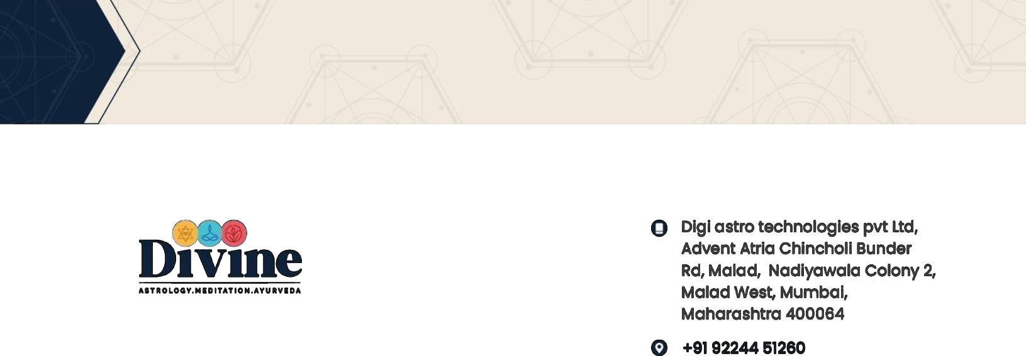

# PROPERTY OF THE COMPANY

1. All work papers, notes, files, memoranda, reports, proposals, deliverables, drawings, blueprints, manuals, materials, data, computer hardware, computer software licenses and any other papers and records of every kind which will come into Internship’s possession at any time after the commencement of Internship’s employment at the Company including any inventions which Internship makes while performing duties for the Company or relating to Confidential Information, will be the sole and exclusive property of the Company. This property will be surrendered to the Company upon termination of the Agreement, or upon request by the Company, at any other time either during or after the termination of this Agreement. Internship also acknowledges and agrees that all work papers, files, memoranda, notes, reports, records and other documents and computer software created, developed, compiled or used by Internship or made available to the Internship during the term of this Agreement including without limitation, all customer data, marketing and sales information, billing information, service data, and other technical materials of the Company is and will be the Company property and will be delivered to the Company within three (3) days after the termination of this Agreement.
2. The Internship agrees that the Internship will be personally liable to the Company and its clients for any data, Confidential Information or property of the Company retained by the Internship after termination of this Agreement or disclosed by the Internship during or after the termination of the employment.

# OTHER TERMS AND CONDITIONS

* 1. It is your responsibility to notify the Company of any change in your personal information inclusive of the change in the address within 3 working days. All notices shall be considered duly and properly delivered to the address on file with the Company.
  2. During the period of service with the Company, you shall not indulge and/ or take part in any activity of formation of the council and/or association or become a member being part of management staff which are found to be detrimental in the interest of the Company in any way. Such an action shall be deemed as an infringement to service conditions of the Company and amount to causing damage to its interest and shall call for disciplinary action being taken against you, as it may deem fit and appropriate.

Any and all of the terms and conditions of service may be modified or changed at the Company’s

discretion.

# ANNEXURE III

SALARY BIFURACTION

The following compensation items are subject to the terms and conditions of your offer letter, to which this Annexure-III is attached. Payments are subject to applicable taxes. Please note that fixed pay and other benefits (if any) are expressed on an annualized basis.

|  |  |
| --- | --- |
| **Internship details:** |  |
| 1.Name: | Abhishek Kumar |
| 2. Position title (Clause 1): | Software Developer Inter |
| 3. Employment commencement date (Clause 1): | 23rd Aug, 2025 |
| 4. Location of employment (Clause 2): | Haryana (Work from Home) |
| 5.Hours of working | Not fix |
| 6. Probationary period (Clause 6): | 3 Months |
| 7. Specify either monthly compensation | INR 5,000/- |



# ANNEXURE IV

NON-DISCLOSURE AND CONFIDENTIALITY AGREEMENT

This Non-disclosure and Confidentiality Agreement (the “Agreement”) is made effective as of 10th September, 2024 between Abhishek Kumar [hereinafter referred as “You”] Operations Intern. And Digi Astro Technologies Private Limited (hereinafter referred to as Company) have registered once at Haryana, also referred to herein collectively as the “Parties” and individually as a ‘Party’ to assure the protection and preservation of the confidential and/or proprietary nature of the information disclosed or made available or to be disclosed or made available, to each other in connection with discussions or negotiations with respect to a prospective and/or ongoing business relationship. The confidential information, invention and the works which form the part of the present Agreement has been defined under the terms of this Agreement.

WHEREAS, the Parties are in the process of evaluating a potential relationship whereby the Company will retain the services for performing “works” which may include developing any code, process, practice, discovery or “invention” along with training, accessing new techniques, know- how for the particular product or system, etc.

WHEREAS, the Company possesses certain information and materials which it considers to be highly confidential and proprietary in nature and which constitutes trade secrets of the Company duly defined in the Clauses of the present Agreement. The trade secrets of the Company shall also include the particular style of conducting the procedures required as suggested by the Company himself.

WHEREAS, the Parties acknowledge and agree that assessment of the potential business relationship between the Parties may require disclosure of certain of this confidential and proprietary information to You as an Internship.

WHEREAS, the Parties desire to assure that the confidential status of the information which may be disclosed to each other is protected from disclosure and is only used for the purpose of the business relationship between the parties as agreed mutually between the Parties.



WHEREAS, the Company desires to assure that upon completion of the business between the parties or termination of the discussions, the confidential information in whatever form as disclosed or provided and the work as completed on basis of such information, must be returned to the Company.

THEREFORE, in consideration of the above agreement set forth herein and the acknowledgement, the parties agree to the following:

# INVENTIONS

Invention means any new or useful art, discovery, new contribution, finding or improvement (including without limitation any technology, computer programs, test, concept, idea, apparatus, device, mechanism, equipment, machinery, process, method, the composition of matter, formula or technique), whether or not patentable, and all know-how related thereto, that has been made, created, developed, written or conceived by You, (i) in the course of my employment, (ii) relating to the actual or anticipated business of the company, or (iii) with the use of the company’s time, material resources, proprietary information and facilities.

# CONFIDENTIAL INFORMATION AND CONFIDENTIALITY

The confidential information means information (i) disclosed to or known by you as a consequence of your employment with the company, (ii) not generally known to others outside the company, (iii) which related to the trade secrets or otherwise to the research, development e orts and methodologies, testing, engineering, manufacturing, marketing, sales, finances or operations (including without limitation any processes, programming, formulae, methods, techniques, know- how, customer lists, sales, sale statistics, projections, marketing strategies and plans and personal information or data) of the company or of any other party including but not limited to customer’s existing or old p]partners, vendors, distributors, service providers, licensors, which has to entrust such information to the company in confidence.

You agree that you shall hold the confidential information in the strictest of confidence and to protect the Confidential Information from disclosure to any third party. You shall take all steps necessary to protect the confidential information from disclosure. The confidential information can be used only for the Business purpose defined above and shall not use any part of it, for your own purposes or the purposes of any other party. You shall advise your Internship(s) if any, working for the furtherance of the Business Purpose that such information is the confidential and proprietary property of the Company and may not be disclosed to others or used for the purpose of the party to whom disclosure is being made.



1. WORKS

It means any materials for which copyright protection may be obtained including without limitation computer programs (including designs, pseudo-code, prototypes, blueprints, internet software and applets) that have been made, created, developed, written or conceived by you (i), (i) in the course of my employment, (ii) relating to the actual or anticipated business of the company, or (iii) with the use of the company’s time, material resources, proprietary information and facilities.

You agree that all the works created by you, alone or with others shall be deemed “Works Made for Hire” under the Intellectual Property Laws and shall be exclusively owned by the Company. You shall promptly disclose to the company in writing all inventions and works which are conceived, made, discovered, written, or created by you alone or jointly with someone else on the company’s time or on your own time while being gainfully employed with the Company.

# ON TERMINATION

On termination of the contract between the parties, you are duty-bound to return the confidential information, invention and works (even if it is authored by you) to the Company, in a safe manner. The entire works done on the basis of the information provided by the Company must be returned to the Company without any fail.

If the work as executed by you is not to the expectations of the Company, the Business Purpose would be deemed to have no existence and the work will be discontinued without any further payments. However, the work and the confidential data must be handed over to the Company.

You shall not be permitted to make, retain or create any other documents, outline, presentation, in any form whatsoever, that includes any of the Confidential Information.



LIABILITIES AND JURISDICTION

You acknowledge and expressly agree that any breach by you of the obligations and commitments outlined in this Agreement, particularly those related to the Business Purpose, may result in substantial harm and financial loss to the Company. Accordingly, you shall be liable for such damages, and the Company shall be entitled to seek enforcement of this Agreement by way of injunctive relief or other equitable remedies as may be ordered by a court of competent jurisdiction.

If any provision of this Agreement is determined by a court to be illegal, invalid, or otherwise unenforceable, such determination shall not affect the validity or enforceability of the remaining provisions, all of which shall continue in full force and effect.

In the event of any dispute arising out of or in connection with the Business Purpose or any other terms of this Agreement, the **courts of Gurugram, Haryana**, shall have **exclusive jurisdiction** to entertain and resolve such disputes.



ANNEXURE V

NON-COMPETE AND NON SOLOCITATION AGREEMENT

This Non-Compete and Non-Solicitation Agreement (“Agreement”) is made effective as of **9th September, 2024**, by and between **Abhishek Kumar**, Operations Intern (hereinafter referred to as “**You**”) and **Digi Astro Technologies Private Limited**, having its registered office at **Gurugram, Haryana** (hereinafter referred to as the “**Company**”) (collectively referred to as the “**Parties**”, and individually as a “**Party**”), for the purpose of protecting the mutual interests of the Parties during and after the course of employment.

* 1. You agree that after the termination of your employment with the Company, for a period of 2 years, you shall not approach, entice, solicit or contract any individual, client, Internship, contractor, service provider, etc. directly or indirectly through any of your relations or associations on behalf of any other Company not shall you induce any Internship or service provider associated with the Company to terminate the contract or business relationship with the Company.
  2. You agree that once the contract with the customer of the company has come to an end or your employment has terminated due to any reason, you shall not work for such customer directly or indirectly for a period of 2 years.
  3. You agree that during your employment and for 1 year after the termination of the employment with the Company, You will not engage in any business activity which is competitive with the Company nor work for any company which competes with the Company.

Further, you agree that you will not for yourself or on behalf of any other person or business enterprise, directly or indirectly through any of your relations or associations, engage in any business activity which competes with the company.

* 1. You agree not to disclose your remuneration and other incentives received from time to time from the Company to anyone else during the term of your employment with the Company.
  2. You agree and shall not directly or indirectly for a period of 10 years disclose to any person, firm or any other company or association regarding the business ethics and business structure inclusive of the strategies that you may have been informed during the



* 1. During the course of your employment, any technical know-how, coding, programming, or other related work acquired or developed by you in association with the Company shall be considered the intellectual property of the Company.

The Parties agree that if any provision of this Agreement is deemed illegal, invalid, or unenforceable by a court of competent jurisdiction, the remaining provisions shall continue to be valid and enforceable to the fullest extent permitted by law.

In the event of any dispute arising out of or in connection with this Agreement, the Courts of **Gurugram, Haryana** shall have exclusive jurisdiction to resolve such disputes.

SINCERELY,

*Paras Shah*

Co-Founder, DIVINE DIGIASTRO

